“FAKE REVIEW DETECTION”
B.E. Project Report

Submitted in partial fulfillment of the requirements

For the degree of
Bachelor of Engineering
in
Computer Engineering

by
Mr. Aaditya Shete ,
Ms. Lalima Sharda,
Mr. Shubham Wankhede,
Ms. Tanvi Chavan

Supervisor

Mrs. Rashmi Dhumal

Department of Computer Engineering
Ramrao Adik Institute of Technology
Dr. D. Y. Patil Vidyanagar, Sector 7, Nerul, Navi Mumbai 400 706.
(Affiliated to University of Mumbai)
October - 2017

Ramrao Adik Institute of Technology
(Affiliated to the University of Mumbai)
Dr. D. Y. Patil Vidyanagar, Sector 7, Nerul, Navi Mumbai 400 706.
CERTIFICATE
This is to certify that, the project ‘A’ titled
“FAKE REVIEW DETECTION”
is a bonafide work done by
Mr. Aaditya Shete ,
Ms. Lalima Sharda,
Mr. Shubham Wankhede,
Ms. Tanvi Chavan
and is submitted in the partial fulfillment of the requirement for the degree of

Bachelor of Engineering
In
Computer Engineering
to the
University of Mumbai


Mrs. Rashmi Dhumal
Supervisor

Mrs. Aditi Chhabria Dr. Leena Ragha Dr. Ramesh Vasappanavara
Project Co-ordinator Head of Department Principal

Project Report Approval for B.E.

This is to certify that the project ‘A’ entitled “Fake Review Detection” is a bonafide work done by Aaditya Shete, Lalima Sharda, Shubham Wankhede and Tanvi Chavan under the supervision of Mrs. Rashmi Dhumal. This dissertation has been approved for the award of Bachelor’s Degree in Computer Engineering, University of Mumbai.

Examiners :
1. . . . . . . . . . . . . . . . . . . . . . . . . . . . . . .

2. . . . . . . . . . . . . . . . . . . . . . . . . . . . . . .

Supervisors :

1. . . . . . . . . . . . . . . . . . . . . . . . . . . . . . .

2. . . . . . . . . . . . . . . . . . . . . . . . . . . . .

Principal :

. . . . . . . . . . . . . . . . . . . . . . . . . . . . . .
Date :
Place :

Declaration

We declare that this written submission represents our ideas in our own words and where other’s ideas or words have been included, we have adequately cited and referenced the original sources. We also declare that we have adhered to all principles of academic honesty and integrity and have not misrepresented or fabricated or falsified any idea/data/fact/source in our submission. We understand that any violation of the above will be cause for disciplinary action by the Institute and can also evoke penal action from the sources which have thus not been properly cited or from whom proper permission has not been taken when needed.

Aaditya Shete | Roll no: 14CE7041
Lalima Sharda | Roll no: 14CE7502

Shubham Wankhede | Roll no: 14CE7005
Tanvi Chavan | Roll no: 14CE7501

ACKNOWLEDGEMENT

No project is ever complete without the guidance of experts who have studied in these fields. So we would like to take this opportunity to thank all those who have helped us in visualizing this project.

We remain immensely obliged to Mrs. Rashmi Dhumal, for providing us invaluable support in garnering resources for this project either by way of information or guidance. We are indebted to our project coordinator Mrs. Aditi Chhabria who made this project happen.

We would like to thank our college Ramrao Adik Institute of Technology, Nerul and our principal Dr. Ramesh Vasappanavara and the H.O.D. of Computer department Dr. Leena Ragha for their valuable support.

We would like to say that it has indeed been a fulfilling experience for working on this project topic.

ABSTRACT
E-commerce is getting enormous day by day if not in every minute. Online Reviews play a very important role in this field and are proving itself to be auspicious in terms of decision making from a customer’s point of view. That is why spamming, fake reviews and fabricated opinions are on the rise. This project spans over the Data Mining and Analysis and Text Mining domains. Data Analytics is increasingly becoming a trending practice with the purpose of constructing valuable information from data. This has led to new challenges faced by experts every day, which includes integration of data from multiple data sources, reliability of the data sources, high-dimensional data, scalability of models, distributed computing etc. Lately, opinion mining has attracted a great deal of research attention, but very few have been able to implement sophisticated techniques in this field. Recent works have been primarily focused on identifying deceptive opinion spams that have been deliberately written in sound authentic language. Other techniques include Natural Language Processing (NLP) that extracts meaningful features from text and then applying various machine learning techniques to conduct review detection. This project uses text features and models to calculate the probability of a review being fake using the Naive Bayes algorithm.

List of Tables
Table Name | Page No.
2.1. Literature Survey Summary | 5
4.1. Gantt Chart | 14

List of Figures
Figure Name | Page No.
3.1 System Architecture | 6
3.2 Basic flow of the system | 8
5.1 Activity Diagram | 15
5.2 Context Level DFD (DFD Level 0) | 16
5.3 DFD Level 1 | 17
5.4 Use Case | 18
5.5 Home Page | 19
5.6 List of top products on home page | 19
5.7Login page | 20
5.8 Displaying details of a product | 20
5.9 Displaying details of a product and its manufacturer’s description | 21
5.10 Displaying customer reviews of a product | 21

INDEX
CHAPTER NO. | SECTION NO. | TOPIC | PAGE NO.
 |  | Acknowledgement  Abstract  List of Tables  List of Figures | iii  iv  v  v
1. | 1.1  1.2  1.3  1.4  1.5 | INTRODUCTION  Overview  Objective  Motivation  Problem Definition  Organization of report | 1  2  2  3  3
2 | 2.1  2.2  2.3 | LITERATURE SURVEY  Research Papers Survey  Similar Existing Project Comparison  Analysis | 4  5  5
3. | 3.1  3.2  3.3  3.4 | PROPOSAL  Problem Statement  Proposed Work  Proposed Methodology  Hardware and Software Requirement | 6  6  7  13
4. | 4.1 | PLANNING AND FORMULATION  Schedule for Project | 14
5. | 5.1 | DESIGN OF SYSTEM  Diagrams with Explanation | 15
6. | 6.1  6.2 | PROPOSED RESULTS  Proposed results and Analysis  Evaluation Parameters | 22  22
7. |  | CONCLUSION | 24
8. |  | FUTURE WORK | 25
9 |  | REFERENCES | 26

Chapter 1: INTRODUCTION
Expressions can take many forms. The number of people expressing themselves is increasing day by day. In case of internet and the web they take the form of blogs, comments, reviews, forums, journals, etc. One of the most widespread forms of expression is reviews. Many sites have made it compulsory for their users to post reviews. Reputation of restaurants, movies and products depend a lot upon the reviews they get from the customers. Today, the world is flocking with E-Commerce stores. Nearly every business venture has an e-commerce platform owing to easy access to the Internet everywhere and knowledge about the procedure. There are a number of parameters which contribute to define the success and credibility of an Ecommerce store. However, one very important factor in elevating the reputation, standard and evaluation of an Ecommerce store is Product Reviews. Not taken much into serious account, Product Reviews provide an Ecommerce store with one of the most valuable resources available: Customer Feedback.

  - Overview
Nearly all the stores claim and commit that their product is the best. We cannot trust their words as a parameter of evaluating different products from different sites. The best judges for a product are the consumer of the product themselves. But all the consumers cannot even theoretically use all the products: this is where Product Reviews come into play. With the help of Product Reviews, a customer knows exactly what he is buying, what he is being offered and what the things he can expect from the product are. According to statistics, nearly 40% of the consumers say that they wouldn’t buy electronic items without reading online reviews about the product. It has been analyzed that traffic in most of the reviewing sites has increased to 96% last year. Instead of actually visiting hundreds of customers and asking for their experience, people find it easier to check out the reviews online. It is found that 88% of people, who made a purchase based on online reviews, found the review to be accurate. This shows how important reviews are. But what if these reviews are incorrect? There are many cases where people either individually or in group, post incorrect reviews about some products. Sometimes these peoples are paid very well. Such types of spam review can be broadly classified into positive and negative reviews. Positive spam reviews try to promote the products they are advertising, their aim is to increases the sales of the product. The latter tries to malign the product reputation so as to decrease the product sale. The effect is worse if a negative spam review is written for a good product, and positive spam review for a bad product. Both these type of reviews are harmful in either way as they totally capture the sentiments of the products, thereby affecting the sale of the product. Such types of reviews should be detected and eliminated to provide users with genuine experience of the business. Our application will give you the promising reviews by filtering them, deleting fake reviews then you can decide whether you want to buy the product or not.

1.2. Objective
Researchers have proposed various fake review detection approaches in the past few years to preserve the accuracy of online opinion mining results. One major task in this area is to distinguish between fake reviews and truthful reviews.
Our main objective is to point out fake reviews so that the customers can purchase the correct product. The proposed system will analyze the opinions and classify them on the basis of fake and real. The system must capture real time reviews and provide efficacy in analysis using classification algorithms i.e. Naïve Bayes.

1.3. Motivation
The reason behind developing this system is that nowadays people heavily depend upon opinions before buying anything. This instigates many spammers to write fraudulent and useless opinions about such products or services.
There are some organizations in the market who hire professionals to write fake reviews and promote their products or defame its competitor’s product. Such fake opinions are misleading the customers and convincing them to buy products which are based on fake opinions. Hence there is a need to devise a tool which can help them to distinguish legitimate reviews from the fake ones, about products, organizations and services. The proposed system will analyze the reviews and classify them as whether they are spam or not. In this project, we introduce a more proactive approach that allows us to differentiate valid and spam review. The main aim is to design and develop a fake review detection system based on the classification algorithm Naïve Bayes.
1.4. Problem Definition
Simply put, we consider the problem of spotting fraudulent reviewers, and consequently spotting fake reviews in online review datasets. The online review datasets mainly consist of a set of users (also called customers, reviewers), a set of products (e.g., hotels, restaurants, etc.), and the reviews. Each review is written from a particular user to a particular product, and contains a star-rating, often an integer from 1 to 5. The reviews are obtained from the website using the scraping technique, and furnished to the system as input. Using various data preprocessing techniques, the data is scrubbed and then applied to the Naive Bayes Algorithm for calculating the probability of the review being fake.

1.5. Organization of Report
Chapter 1 provides the problem statement, objective, motivation, and scope as an introduction of the entire report. The rest of the report is organized as follows: The literature and existing projects survey is carried out in Chapter 2 followed by an analysis of latest emerging trends. We have defined our proposal and a detailed work up in Chapter 3. A detailed timeline of the execution plan is presented in Chapter 4. Chapter 5 deals with the design of the system, including the UML diagrams, GUI mock ups and appropriate descriptions. Chapter 6 lays out the proposed results for the system in detail and the results and concluding remarks are presented in Chapter 7. Any future refinements and updates that we have identified have been described in Chapter 8.

Chapter 2: LITERATURE SURVEY
Following section is a survey of some of the scholarly works done by researchers in this particular domain. It includes current knowledge including substantive findings as well as theoretical and methodological contributions.

2.1. Research Paper Survey
A study showing efficacy in classifying product review by semantic meaning in [2] proposes an approach that incorporates spelling correction in review text and then employing a hybrid of Decision Trees and Naive Bayes algorithm. First, a web crawler is used to fetch comments from a particular web page. Then spelling corrections are carried out to make the comment more sensible and for knowing the polarity of words using Word Net dictionary. Then stemming is performed to remove the stop words. After classifying the positive and negative words using Naïve Bayes algorithm, the overall polarity is calculated using decision tree.

Shathi, Hossain and Nadim in [3] introduces a Weight Matrix during training text documents which is a combination of term frequency (TF) and inverse class frequency (ICF) and later this weighted term is powered by a significant number and added with the posteriori value during the prediction time of Naive Bayes algorithm to establish a better and efficient performance of classification task. The precedence base element TF results an additional weight for each word whereas, ICF gives each common word a low score. Thus, the combined term “Weighted Matrix” balances weight where necessary. The result shows an improvement in performance accuracy of the Naive Bayes classifier on a small size dataset.

The study proposed in paper [4] improves the accuracy of Naive Bayes classification using improved information gain, one of methods of feature extraction, by reducing the impact of low-frequency words. In this paper, a wide corpus of NLTK is used. According to the test results, the accuracy of the classification improved significantly. Experimental result showed that the information gain method reduces the influence of low frequency words. The method brought about improvement in the accuracy of text classification, but the time complexity and space complexity of algorithm, requires further research. Movie Review Corpus were classified by the degree of preference of movies for audience, and divided into positive and negative , the count of each of positive and negative is 1000. Currently, the corpus is used more emotion classification field corpus.

2.2. Similar existing project comparison
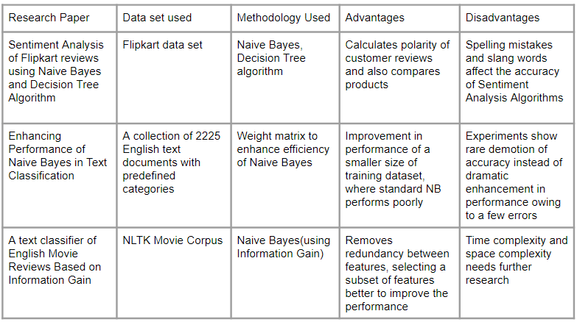
Table 2.1: Literature Survey Summary
2.3. Analysis
When we compare the existing projects with the proposed system, it is clear that there has been extensive research done towards the improvement of efficiency of Naïve Bayes by combining different techniques and applying them on different types of data sets for text classification. The system proposed in this paper is inclined towards applying standard Naïve Bayes on product reviews and classify them as fake or real. The text classifier in [4], despite its advantages, lags in terms of Memory and CPU usage as compared to standard NB algorithm. Similarly, [2] and [3] show inaccuracies in terms of unknown words and large review data sets. To overcome the problem of unknown words, the algorithm will be trained using a large Amazon dataset, attempting to cover as many words as possible in the system.
Chapter 3: PROPOSAL
After a broad research on this topic, we have compiled a methodology for recognizing fake reviews and eliminating them.
3.1. Problem Definition
Simply put, we consider the problem of spotting fraudulent reviews, and consequently spotting fake reviewers in online review datasets. These fake reviews mislead the customers into buying products which are fake or defective. This may lead to loss for the customer and illegal profits for corrupt organizations. Naive Bayes Algorithm is chosen as it is one of the most preferred and popular algorithms in the text classification domains.
3.2. Proposed Work
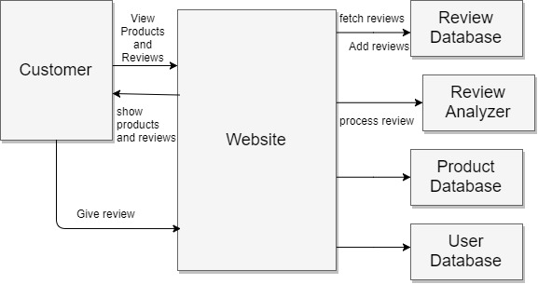
Figure 3.1: System architecture of the fake review detection system

People come across various reviews on a website but whether these reviews are genuine or fake cannot be identified by the user. In some review websites some good reviews are added by the product company people itself in order to make their products famous. User will not be able to find out whether the review is genuine or fake. As illustrated in the diagram, this system will find out fake reviews made by such people by identifying the IP address particular to a reviewer. The detection system scrapes the reviews from the website. It takes real time reviews from websites and analyses them. Referring fig 3.1, the process starts with preprocessing of input data which scrubs the reviews for spelling mistakes, slangs, or stop words. Once the keywords have been extracted from the review, they are fed to the Naive Bayes algorithm for further analysis. If the review is fake, it will be flagged and the user will be blocked. Following are the steps that are performed by the system:
- This system will find out fake reviews made by the groups by identifying the IP address.
- User will be provided with a login interface to the system, and using his user id and password he can view various products and give review about the product.
- While reviewing he will enter the email id from which he is reviewing which would be verified.
- Verification of review will be done by applying Naive Bayes after which the review is classified as authentic or fake.
- If the review is fake, the user is alerted and the reviewer is blocked.
3.3. Proposed Methodology
The proposed system will analyze the reviews and classify them as whether they are spam or not. In this project, we introduce a more proactive approach that allows us to differentiate valid and spam review. The main aim is to design and develop a fake review detection system based on the classification algorithm Naïve Bayes. Following is modus operandi of our project:
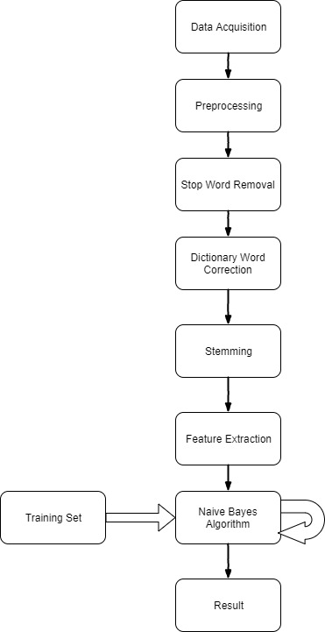
Figure 3.2: Basic flow of the system
Data Acquisition
Using a set of labelled data sets from Amazon, the Naive Bayes algorithm is trained as shown in fig 3.2. For un-labelled data, the Amazon live web page is scraped for new reviews and then preprocessed for the learning method.

Preprocessing
As shown in fig 3.2, we next apply a number of preprocessing techniques to deal with noisy, missing, and inconsistent data which might disturb decision-making process. Low-quality data will produce poor quality mining results and classification results. We ensure that the quality of the data we use in this experiment is up to the mark.

Stop Word Removal
Any word that may not contribute to the classification of the review as fake or real is removed in this step (fig 3.2). Stop words are basically a set of commonly used words in any language, not just English. The reason why stop words are critical to many applications is that, if we remove the words that are very commonly used in a given language, we can focus on the important words instead.

Dictionary Word Correction
The remaining words are then checked for common typing or spelling mistakes and based on a Standard English dictionary, it is corrected accordingly. This is an important step in terms of vocabulary scrubbing so that the next step as shown in fig 3.2 can be efficiently implemented.

Stemming
It is a process of reducing words to their root form (generally a written word form). The purpose is to discern the nature of the word and understand its context. From the words deducted from the above steps, root words are extracted based on the Stanford Core NLP Library (fig 3.2).

Feature Extraction
This step (fig 3.2) starts with an initial set of labelled parts-of-speech data, i.e., the training set. Based on the derived values, it facilitates subsequent learning from new data. The words thus generated are labelled with the category of parts-of-speech they belong to base on the context.

Naive Bayes Classifier Introductory Overview
The Naive Bayes Classifier technique is based on the so-called Bayesian theorem and is particularly suited when the dimensionality of the inputs is high. Despite its simplicity, Naive Bayes can often outperform more sophisticated classification methods.
In order to understand how naive Bayes classifiers work, we have to briefly recapitulate the concept of Bayes’ rule. The probability model that was formulated by Thomas Bayes (1701-1761) is quite simple yet powerful; it can be written down in simple words as follows:
…. eq (3.1)
Bayes’ theorem forms the core of the whole concept of naive Bayes classification. The posterior probability (eqn 3.1), in the context of a classification problem, can be interpreted as: “What is the probability that a particular object belongs to class ii given its observed feature values?”
Let
- xixi be the feature vector of sample i,i∈{1,2,...,n}i,i∈{1,2,...,n} ,
- ωjωj be the notation of class j,j∈{1,2,...,m}j,j∈{1,2,...,m} ,
- and P(xi∣ωj)P(xi∣ωj) be the probability of observing sample xixi given that is belongs to class ωjωj .

The general notation of the posterior probability can be written as
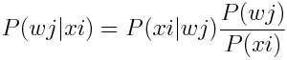 …. eq (3.2)
The objective function in the naive Bayes probability is to maximize the posterior probability given the training data in order to formulate the decision rule.
An additional assumption of naive Bayes classifiers is the conditional independence of features. Under this naive assumption, the class-conditional probabilities or (likelihoods) of the samples can be directly estimated from the training data instead of evaluating all possibilities of x. Thus, given a d -dimensional feature vector x, the class conditional probability can be calculated as follows:
…. eq(3.3)
Using this we can estimate whether the review is fake or real. We will determine the value of conditional probability of the review being real P(review|real) and the conditional probability of the review being fake P(review|fake). Since the function of naive Bayes is to maximize the posterior probability hence if the value of P(review|real) is greater than P(review|fake) then the review is real or else it is fake.
Text Classification using Naive Bayes
The Naïve Bayes Text Classifier is first trained using the labelled Amazon Review Dataset. After that, it is used for processing of unlabeled data. Following sections elucidates the process step wise.
For Training
Step 1: Create a table for the reviews against the different classes (i.e. real or fake).
Step 2: Extract the unique words from the review. Create a frequency table for the number of times a word has occurred in a fake or real review.
Step 3: Calculate the conditional probability of occurrence of all the words in real and fake reviews by using
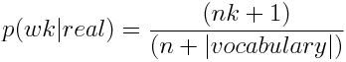 …. eq(3.4)
Where w_{k} is the unique word, n_{k} is its occurrence in real reviews, n is the total number of words in real reviews and vocabulary is the total number of unique words.
Step 4: Similarly compute conditional probability of occurrence of all the words in fake reviews by using
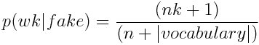 …. eq(3.5)
For Prediction
Step 1: Compute
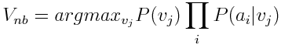 …. eq(3.6)
for v_{j} = real and v_{j}=fake. A_{i} is the word.
Step 2: If V_{NB} for v_{j} = real is greater than V_{NB} for v_{j} = fake then the review is real or else the review is fake.
Step 3: Calculate the conditional probability of occurrence of all the words in real and fake reviews by using equation 3.5 i.e,
3.4. System Requirements
Software Requirements:
The technologies involved in this project are:
- Programming language: Java
- Front End: HTML5, CSS3
- Database: MySQL
Hardware Requirements:
- Processor: Pentium 4
- RAM: 4 GB or more
- Hard disk: 16 GB or more
- Network: Internet connection
Chapter 4: PLANNING AND FORMULATION
4.1. Schedule of the project
By studying the project extensively, we developed a Gantt chart to track and schedule the project. Below is the Gantt chart illustrating the approximate starting and ending of this entire project. It also shows the work breakdown into various phases along the timeline.

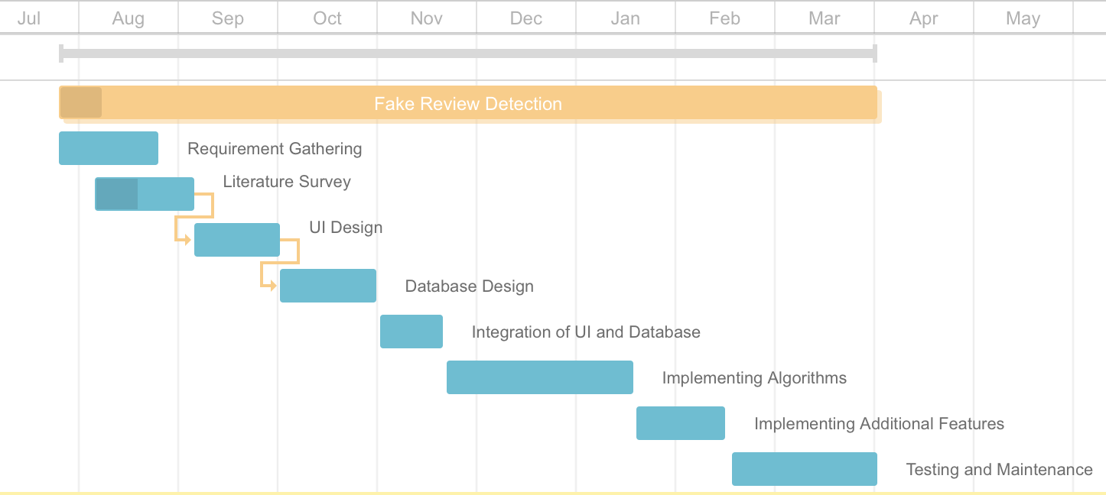
Table 4.1: Gantt chart

Chapter 5: DESIGN OF THE SYSTEM
This chapter deals with the designing part of the software. In this chapter we would be studying the system with the help of various UML diagrams and understand the roles played by different entities and the flow of the system.
The following Activity Diagram fig 5.1 gives the overall process of giving a review and checking its authenticity.
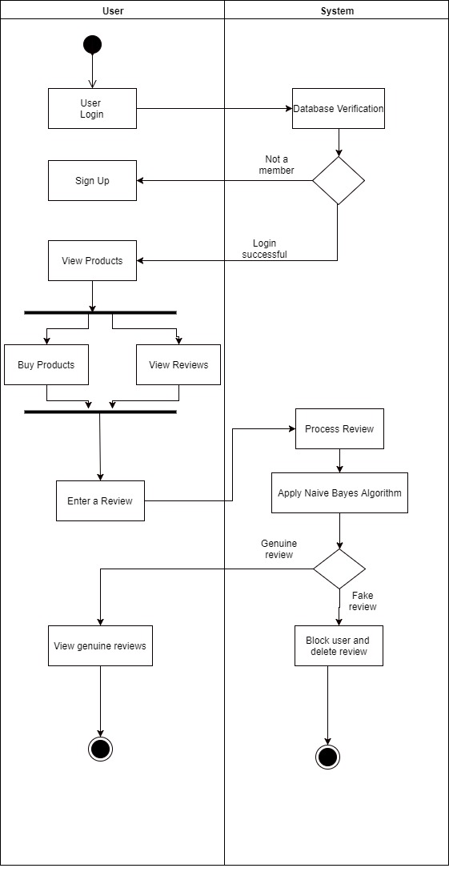
Figure 5.1: Activity Diagram

DATA FLOW DIAGRAM:
A DFD is often used as a preliminary step to create an overview of the system without going into great detail, which can later be elaborated. DFDs can also be used for the visualization of data processing (structured design).The following diagrams illustrates the information flow and the transforms that are applied to the system as it moves through the levels. Each partitioned levels represent increase in information flow and detailed functionality.

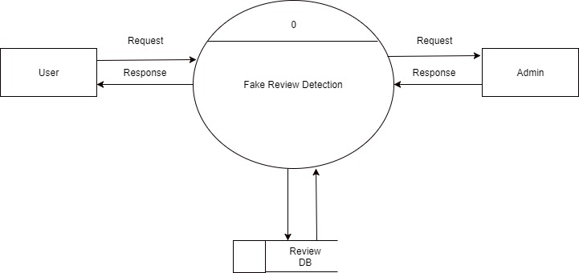
Figure 5.2: Context Level DFD (DFD Level 0)

The fig 5.2 describes the overall functionality of the software. It shows the system’s major processes and identifies manageable sub processes. The figure also illustrates how different components interact with this system.

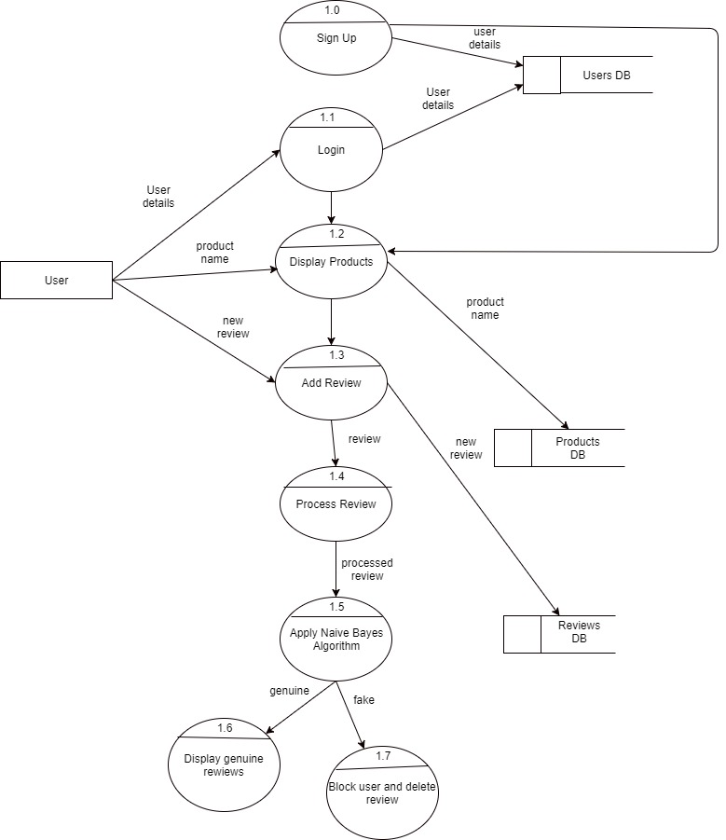
Figure 5.3: DFD Level 1

Level 1 DFD (fig 5.3) shows the details of the scheduling and feedback mechanism. It identifies actual data flows and data stores at high level of abstraction. Expanding the processes in fig 5.2, this illustration shows a deeper understanding of how the user can benefit from this system.
USE CASE:
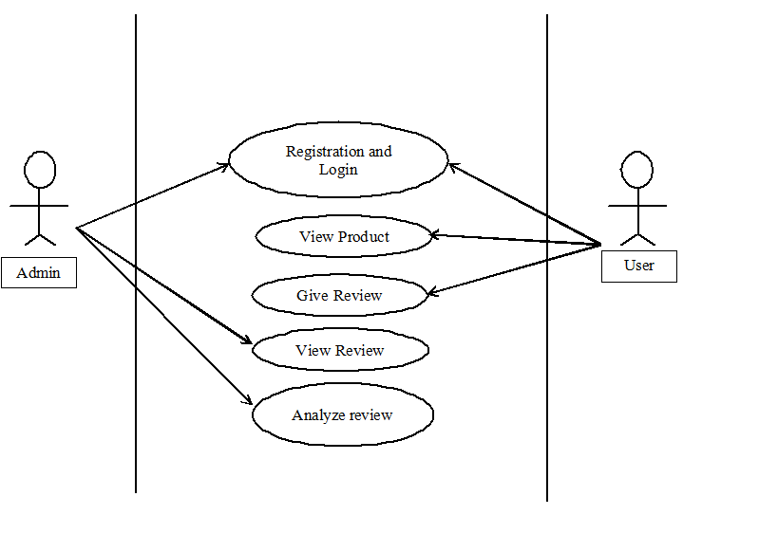
Figure 5.4: Use case diagram of a scenario

Fig 5.4 show the use-case diagram of a scenario in the Fake Review application. It helps us understand various functional requirements of the system and also describes the role of each user. Roles of the actors, here the Admin and the User, as interpreted from the use-case diagrams have been discussed below:
ADMIN: Admin authenticates and validates the user. After the user posts his reviews, the admin can view and analyze the review to categorize it as genuine or fake.
USER: User registers with the system and logs in with his username and password, views the products and gives his review for a particular product.

GRAPHICAL USER INTERFACE:
Following are the screen shots of how our interface would look like before fake review detection:

Figure 5.5: Home Page
Figure 5.5 displays how the system’s home page would look like, as it showcases the current offers on various products.
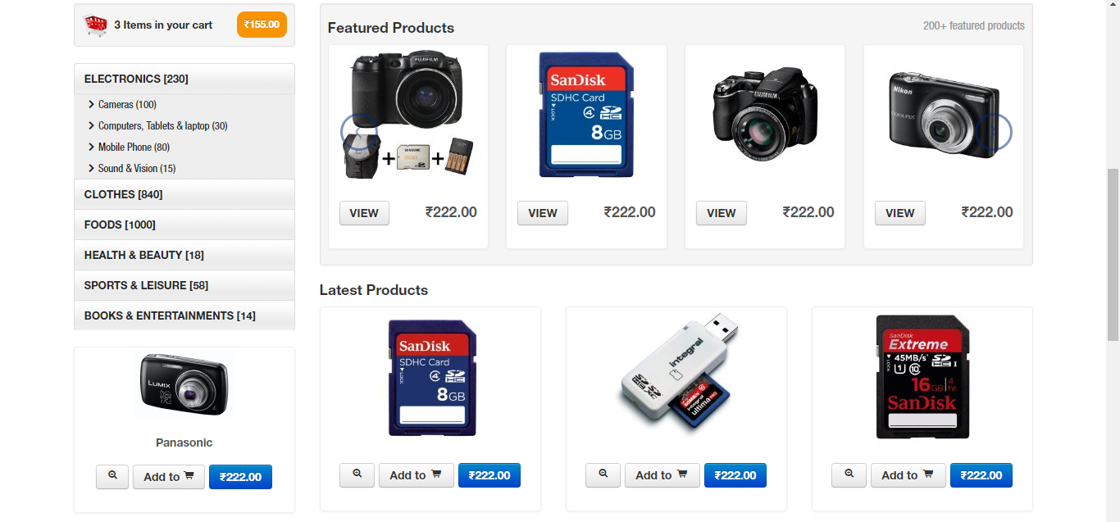
Figure 5.6: List of products on home page
Figure 5.6 is the second part of the above page on scrolling down, displaying the latest or the most popular products.
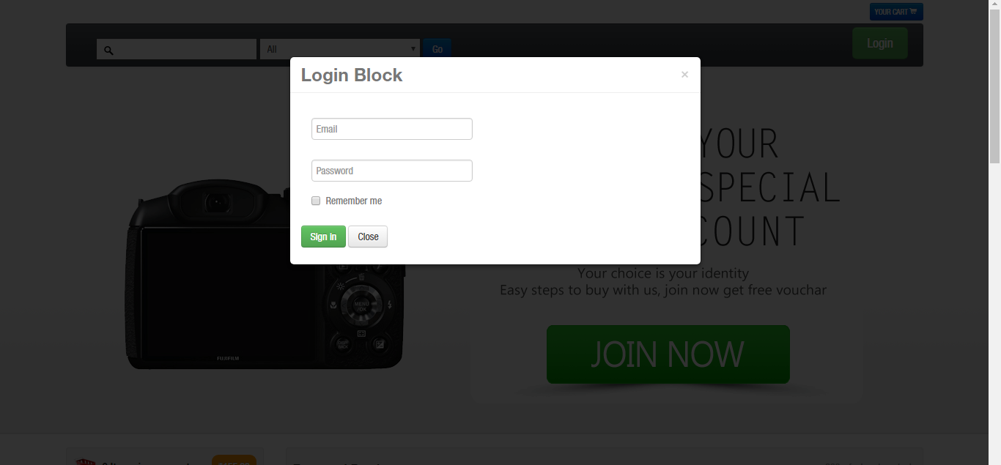
Figure 5.7: Login page
As shown in fig 5.3, the system provides a login page as shown above in fig 5.7. A new user can only avail the services by signing up for an account.
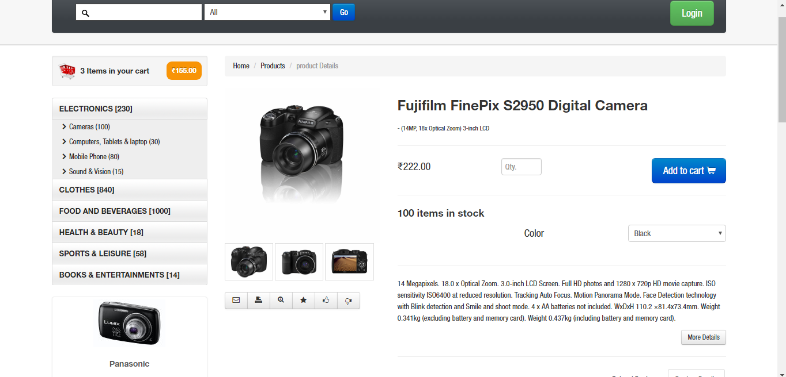
Figure 5.8: Displaying details of a product
Once the user is logged into the system, he can view various products and their details as shown above in fig 5.8.

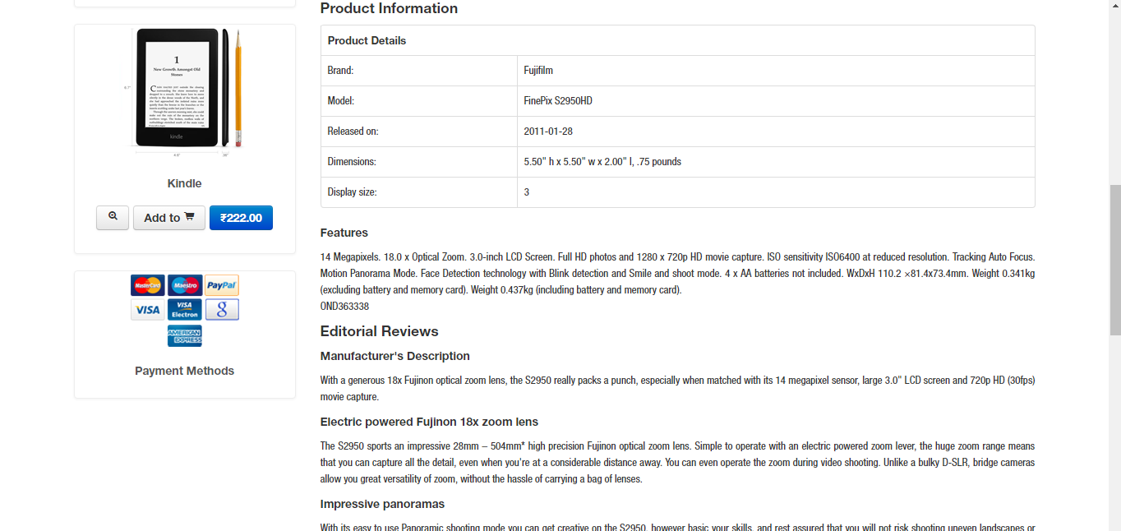

Figure 5.9: Displaying details of a product and its manufacturer’s description
Fig 5.9 shows how the manufacturer’s descriptions of each product will be displayed. The data about the products are scrapped from the Amazon website live, updated as and when it is required.

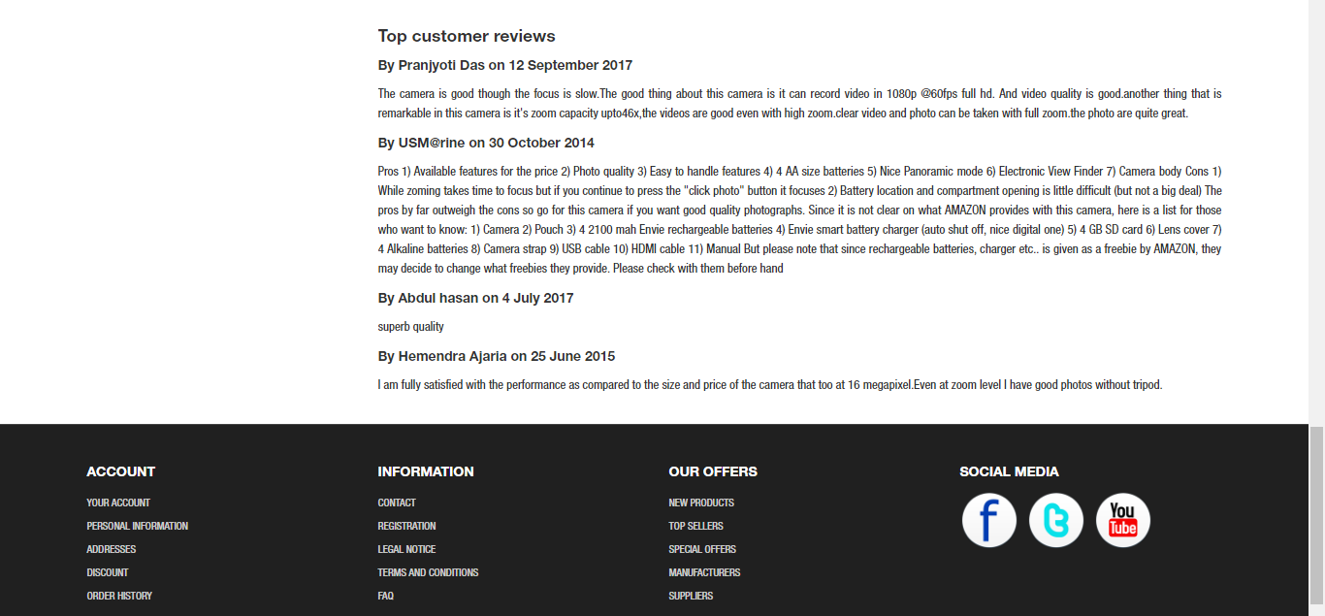
Figure 5.10: Displaying customer reviews of a product
Fig 5.10 shows various user reviews of each product sorted according to date of reviewing. The reviews are scrapped from the Amazon website live, updated as and when it is required.

Chapter 6: PROPOSED RESULTS AND ANALYSIS
The goal of this initiative is largely influenced by employment of a new technique of review classification using Naïve Bayes that overcomes the current problems as reviewed in the literature survey.

6.1. Proposed Results
The final product must be able to classify fake reviews and genuine reviews accurately and alert buyers of any fake reviews present and also facilitate blocking of such malicious users. Efficiency and accuracy a system must be calculated based on the input parameters of the system and the ultimate goal the project is aiming to achieve.

6.2. Evaluation Parameters
The efficiency parameters that will be used to tally the results are as follows:

True Positives (TP) - These are the correctly predicted positive values which means that the review class is genuine and the result predicted is also genuine.

True Negatives (TN) - These are the correctly predicted fake reviews which means that the review class is fake and value of predicted class is also fake.

False Positives (FP) – When actual review class is fake and predicted class is genuine.

False Negatives (FN) – When actual review class is genuine but predicted class in fake.

Once these four parameters have been defined, we can calculate Accuracy, Precision, Recall and F1 score as follows:

Accuracy is the most intuitive performance measure and it is simply a ratio of correctly predicted observation to the total observations and it is equated as follows:
Accuracy = (TP+TN) ÷ (TP+FP+FN+TN) …. eq(6.1)
Precision is the ratio of correctly predicted positive observations to the total predicted positive observations
Precision = TP ÷ (TP+FP) …. eq(6.2)

Recall is the ratio of correctly predicted positive observations to the all observations in actual class.
Recall = TP ÷ (TP+FN) …. eq(6.3)

F1 Score is the weighted average of Precision and Recall. Therefore, this score takes both false positives and false negatives into account.
F1 Score = 2 × (Recall × Precision) ÷ (Recall + Precision) …. eq(6.4)

Performance measure is done in the testing phase and can be calculated by how accurately and how frequently the reviews are classified as real or fake. A detailed approach based on features of the text is shown in [6].
Chapter 7: CONCLUSION

It has been observed from the analysis that customers buy various products from various e-commerce websites by reading the reviews the product has so far. But the customer has no idea whether those reviews are authentic or not. The main objective of the project is to remove those fraudulent reviews and give the customer a good online shopping experience as well as to save the customer’s precious time and money.
The main features of the software includes flexibility, quickness, convenience, reliability and efficiency as well as it provides an easy way to detect fake reviews. The software could very well be enhanced further as per the requirements. There exist other kinds of review or reviewer related features that are likely to make a contribution to the prediction task. In the future, we could further investigate different kinds of features to make more accurate predictions.

Chapter 8: FUTURE WORK

The following are some modifications or possible up gradation that can be pursued in the future:

- Duplicate review detection: Many time reviews are just simply copied, and are used to inflate the positive and/or negative opinion. We would like to be able to detect those reviews.
- “Meat” of the review: In some cases, the whole review is a spam which turns out to be a sale ad or something completely unrelated. It will be good for the system to tag the part of the review that is most likely related to the product (actual review) and those who are unlikely to be related. Furthermore, the less domain knowledge required the better.
- Evaluating the likelihood of fake review: So far our system flags potential problems to the user without quantifying the likelihood of the review is actually a fake. While we see that as a non-trivial problem, maybe more elaborate machine learning techniques can help us generate such likelihoods.

REFERENCES
[1]M.N. Istiaq Ahsan, Tamzid Nahian, Abdullah All Kafi, Md. Ismail Hossain, Faisal Muhammad Shah “Review Spam Detection using Active Learning.” Department of Computer Science & Engineering Ahsanullah University of Science & Technology 2016 IEEE.
[2]“Sentimental Analysis of Flipkart reviews using Naïve Bayes and Decision Tree algorithm” - Gurneet Kaur, Abhinash Singla, International Journal of Advanced Research in Computer Engineering & Technology (IJARCET) Volume 5 Issue 1, January 2016
[3]“Enhancing Performance of Naive Bayes in text Classification of Introducing an Extra Weight using less number of training samples” - Shahnaj Parvin Shathi, Md. Delowar Hossain, Md. Nadim, Sayed Golam Rasul Riyadh, Tangina Sultana, Department of Computer Science and Engineering, Department of Electronics and Communication Engineering, Hajee Mohammad Danesh Science and Technology University,Bangladesh
[4]“A text classifier of English Movie Reviews Based on Information Gain” - Lianjing Jin, Wei Gong, Wenlong Fu, Hongbin Wu, Information Engineering School,Communication University of China,CUC Key Laboratory of Acoustic Visual Technology and Intelligent Control System,Ministry of Culture Beijing Key Laboratory of Modern Entertainment Technology Beijing, China
[5]Lim, Ee-Peng, et al. "Detecting product review spammers using rating behaviors." Proceedings of the 19th ACM international conference on Information and knowledge management. ACM, 2010.
[6]Performance Analysis and Improvement of Naïve Bayes in Text Classification – Wei Zhang, Feng Gao, IEEE
[7]”Some Effective Techniques for Naïve Bayes Text Classification” – Sang-Bum Kim, Kyoung-Soo Han, Hae-Chang Rim, and Sung Hyon Myaeng

